Exp 6
Krishna Maurya
500120521

Here I have created Packages for quires given in questions here !
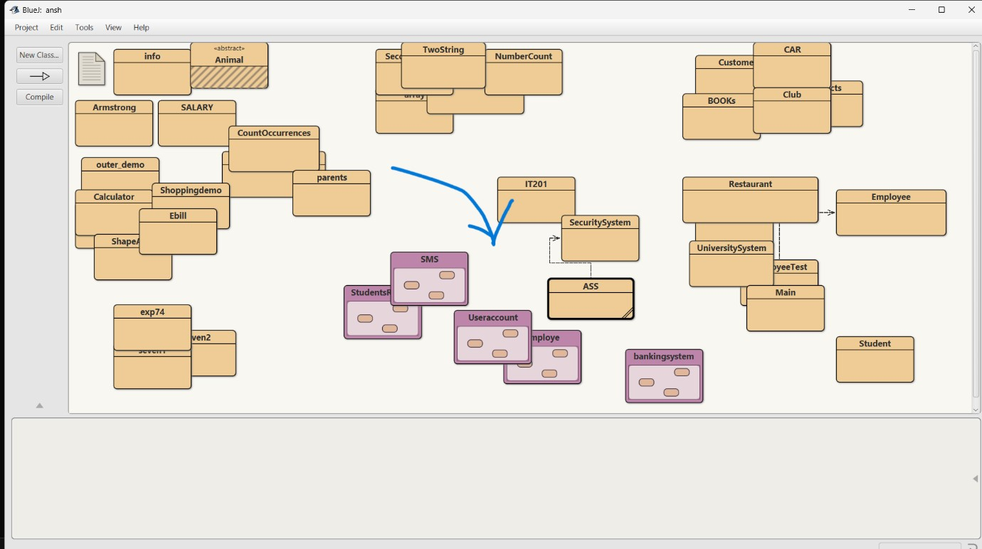

- Imagine you are developing an Employee Management System, where employee details need to be maintained securely. Create a package named
EmployeeManagement that contains a class Employee with attributes such as name, id, and salary. The class should also have a method displayDetails() that prints employee information. Then, create another program outside the
EmployeeManagement package that imports the package and utilizes the Employee class to create an employee object and display their details. Ensure that the package maintains encapsulation while allowing controlled access to employee information.

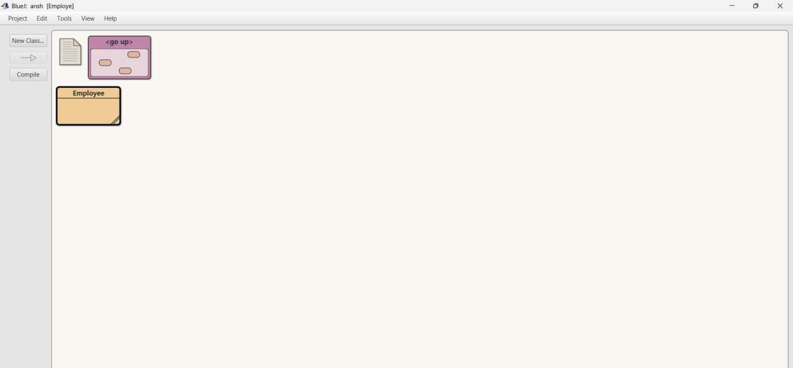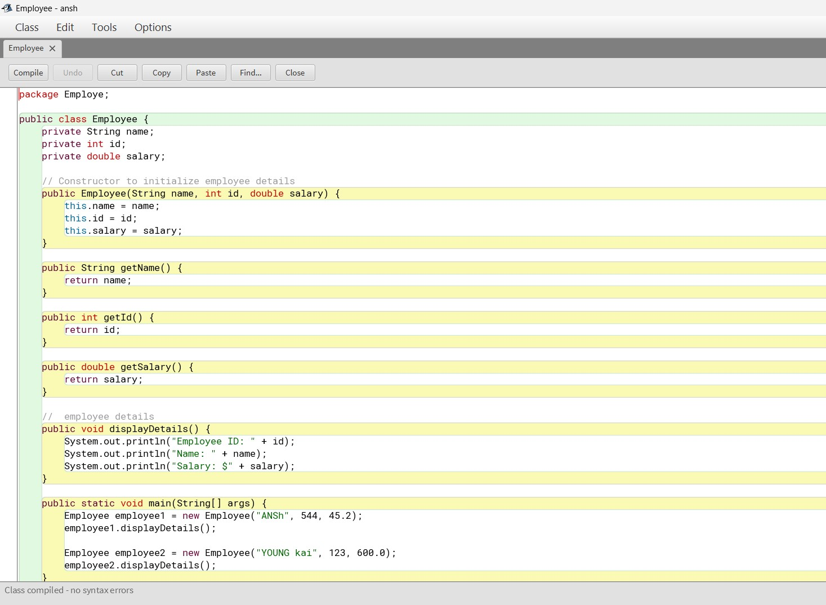

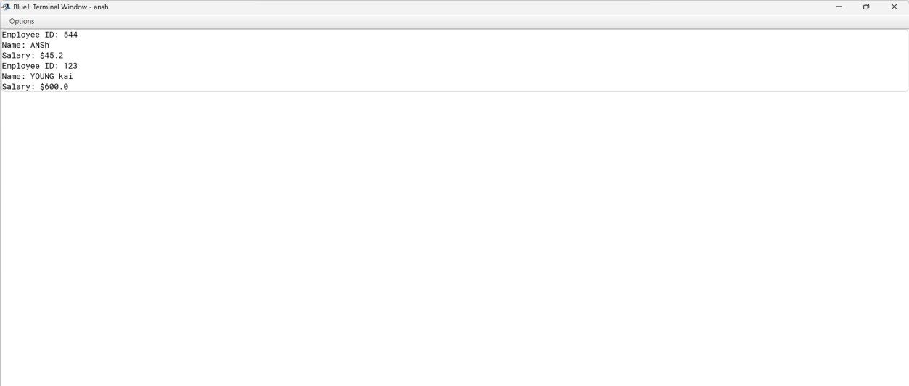

- In a Banking System, different types of users, such as bank employees and customers, need access to account operations with varying permissions. Create a package named BankingSystem containing a class BankAccount that has four methods with different access modifiers: a public method deposit() for adding money, a protected method withdraw() for authorized transactions, a default-access method checkBalance() to be accessed within the same package, and a private method calculateInterest() to compute interest internally. Then, create another package named UserAccount with a class Customer that tries to access these methods from an instance of BankAccount. Demonstrate which methods are accessible and explain why some cannot be accessed based on Java’s access modifier rules.
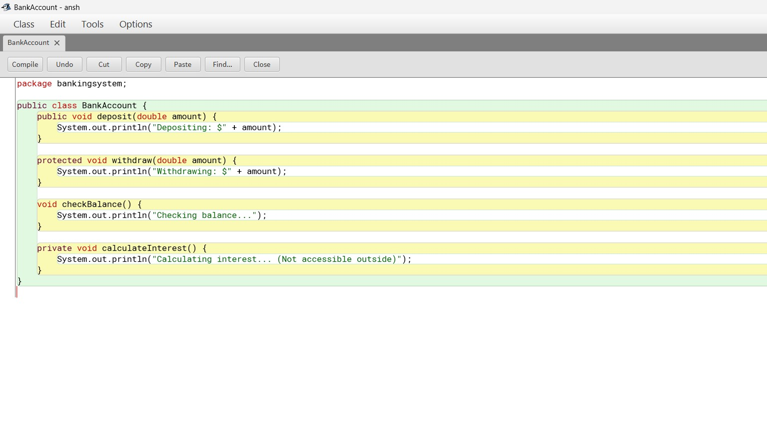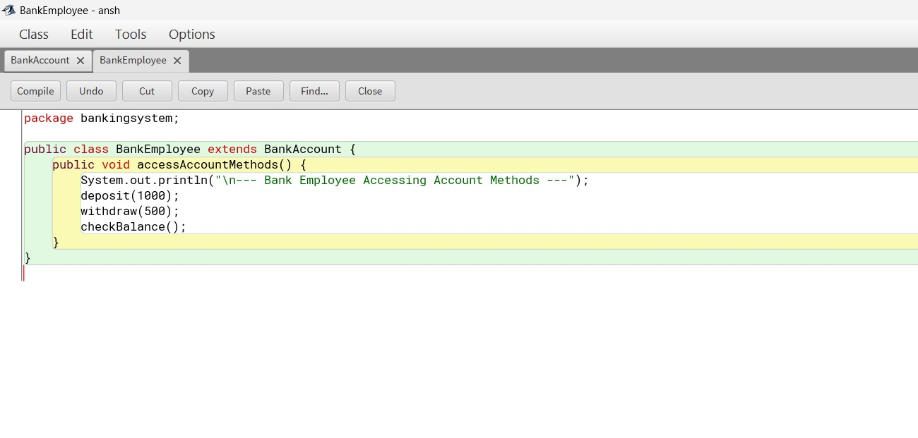

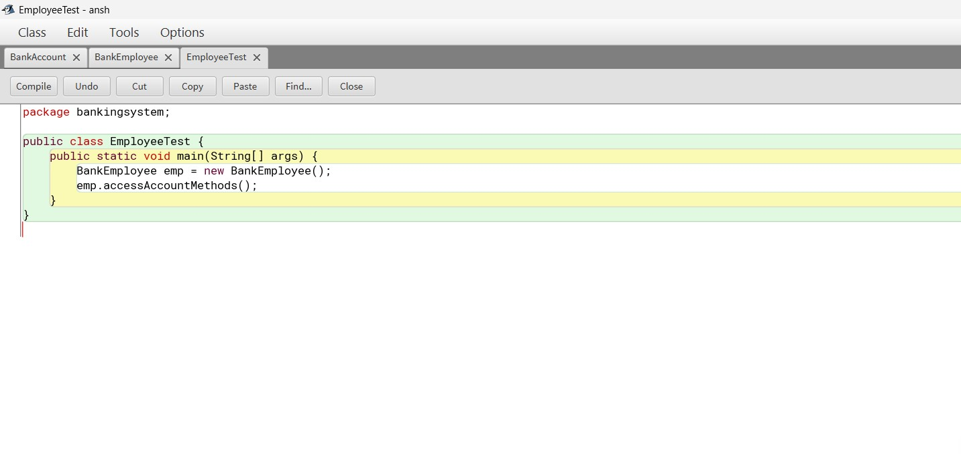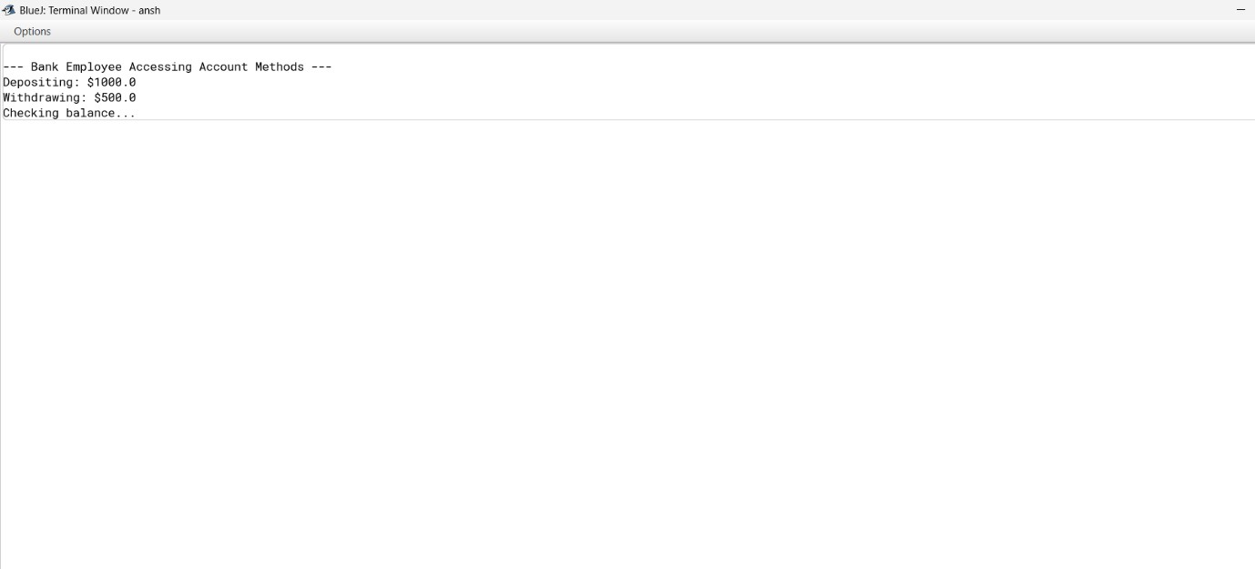

- In a Student Records Management System, personal and academic details of students need to be stored securely while providing controlled access to their data. Create a package named StudentRecords containing a class Student with private attributes studentId, name, and grade. Provide a public constructor to initialize these attributes and a method displayStudentInfo() to print student details. Then, write another program outside the package that imports StudentRecords, creates Student objects, and displays their details. This exercise will illustrate how encapsulation is maintained in Java, allowing data to be accessed only through well-defined public methods while preventing direct modification of private fields.

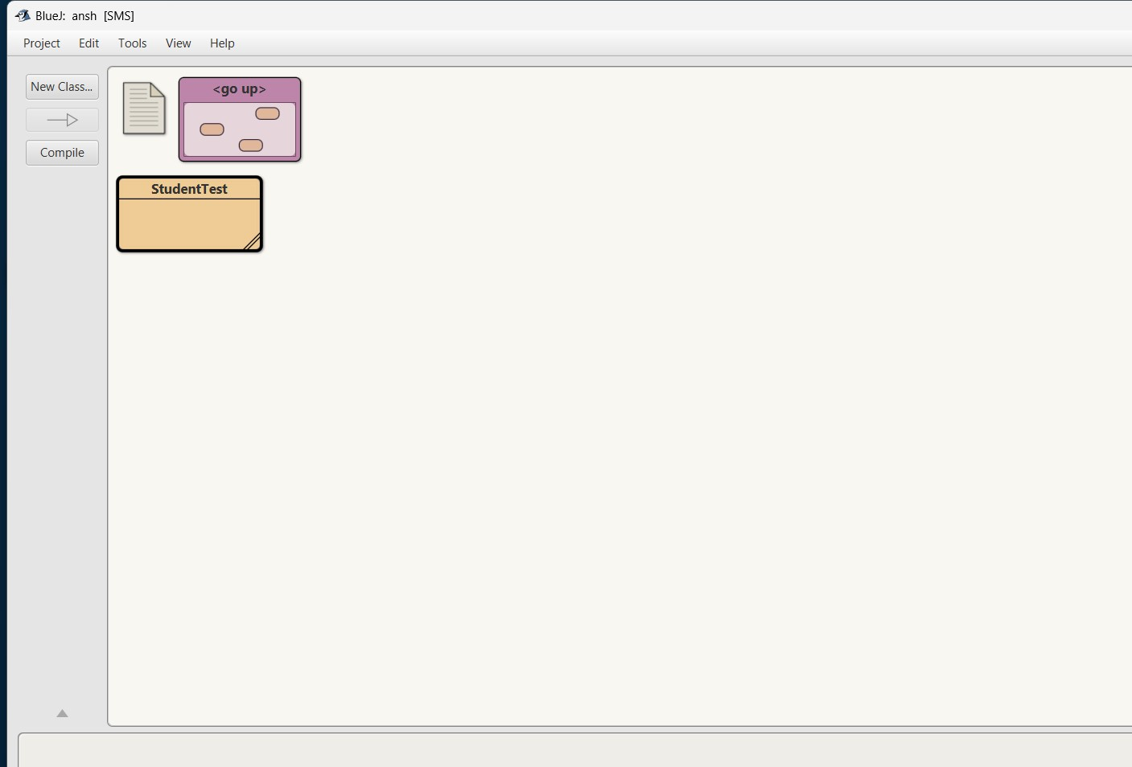
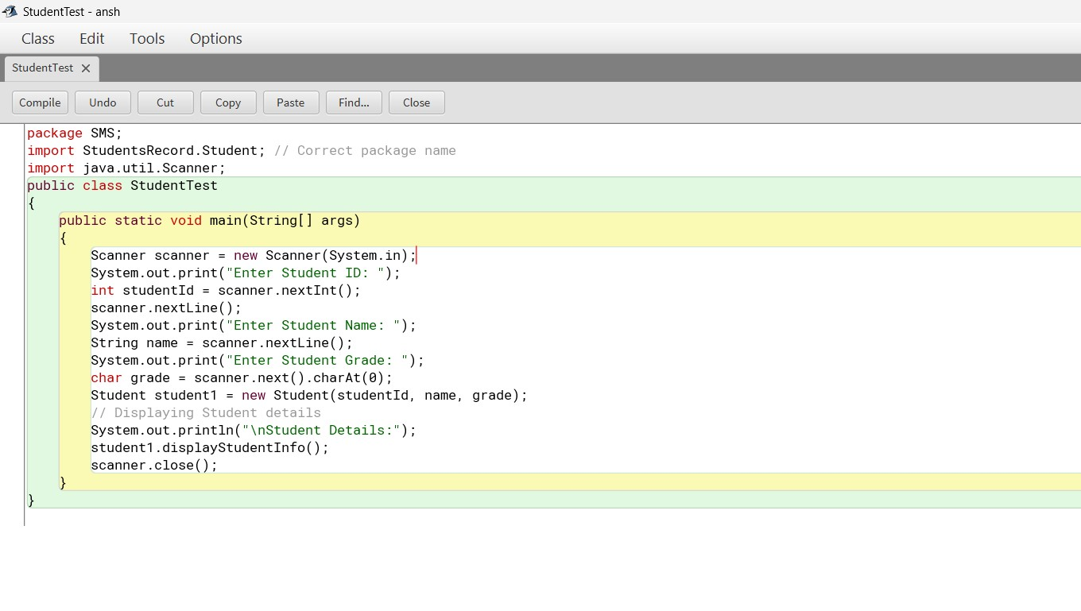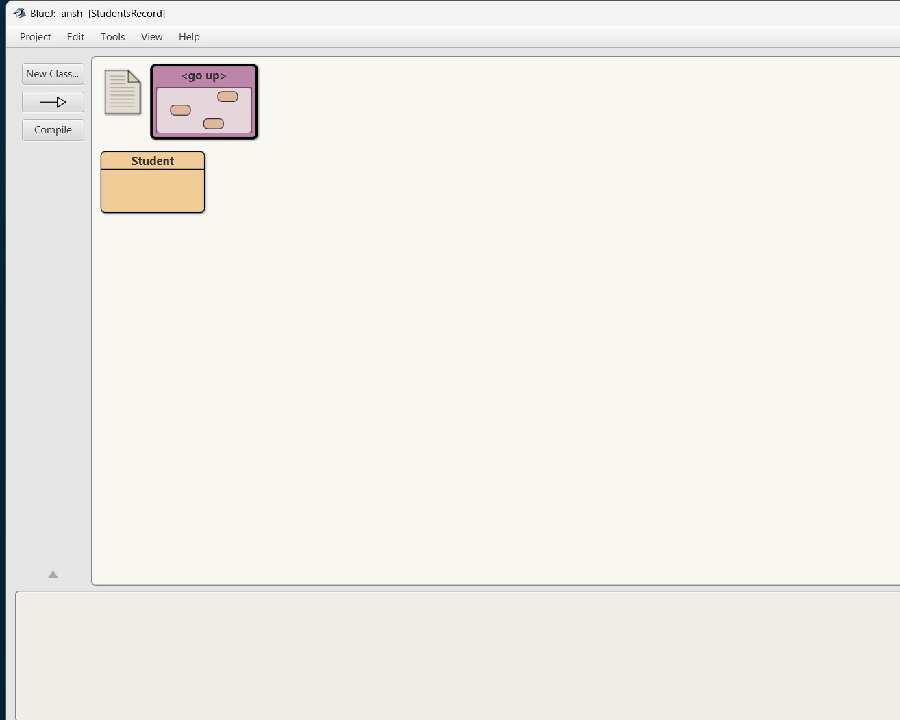

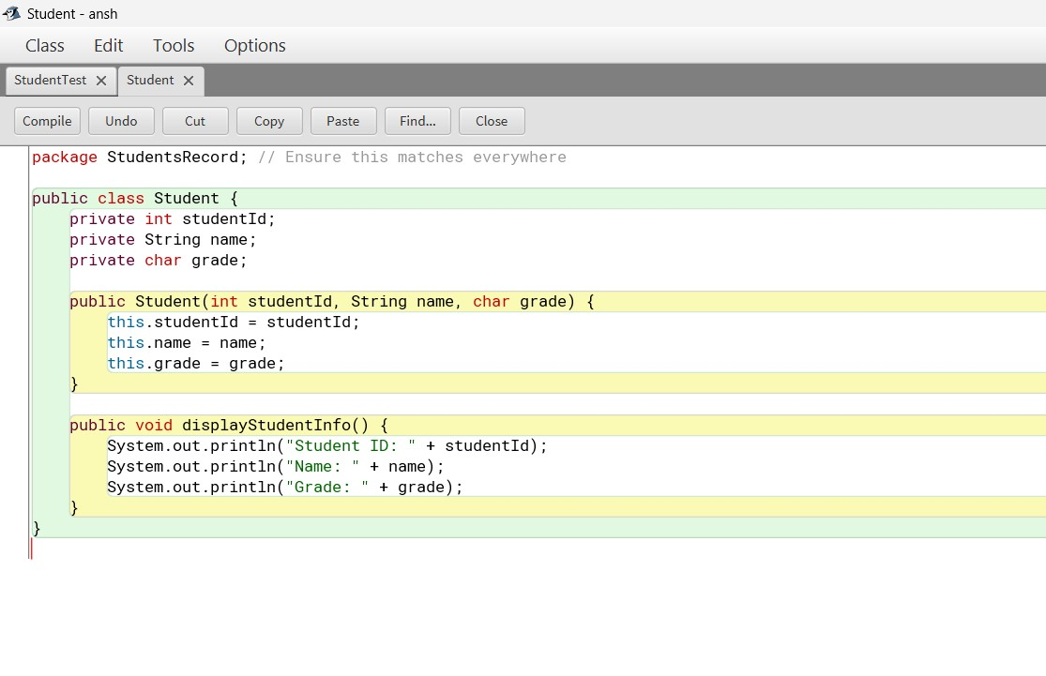

/YourProjectFolder
│── /StudentsRecord
│ ├── Student.java
│── /SMS
│ ├── StudentTest.java

- A security system needs to protect its authentication mechanism to prevent tampering. Implement a final class named SecuritySystem that includes a method authenticateUser(String username, String password), which verifies user credentials. Then, attempt to create a subclass AdvancedSecurity that tries to extend
SecuritySystem and override authenticateUser(). Observe the compilation error and explain why a final class cannot be inherited. In the main() method, create an instance of SecuritySystem and use the authenticateUser() method to validate login credentials. This will demonstrate how the final keyword enforces security by preventing unauthorized modifications to authentication logic

